**Lab 5 – SQL**

**Each problem is worth one point. This lab is worth a total of 20 points.**

**From this lab forward, please notice if a result table is in a particular order. If it is, you must use the order by clause. Failure to do so will result in point deductions for that specific problem.**

**Place all answers into ONE .sql file and upload to Canvas.**

**\*\*\*\* Use the AP table space for the following questions \*\*\*\***

**1. Display the number of rows in the Invoice table.**



**2. Display the number of non-null values of payment_date. Use the Invoice table.**



**3. Display the number of null values of payment_date. Use the Invoice table.**



**4. Display all of the different payment_dates. Use the Invoice table.**

**Partial Result Table (41 rows total)**

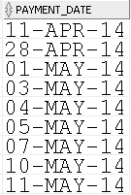

**5. Display the number of different payment_dates. Use the Invoice table.**



**6. Display the total amount of the invoices. Use the Invoice table.**



**7. Display the average amount of the invoice totals. Use the Invoice table.**



**8. Display the average amount of the invoice totals. Use the Invoice table.**



**9. Display the lowest and highest invoice total. Use the Invoice table.**



**10. Display the lowest and highest invoice total. Use the Invoice table.**



**11. Display the last vendor in the alphabetic sort sequence. Use the Vendor table.**



**12. Display the earliest invoice date. Use the Invoices table.**



**13. Display the number of invoices by date. Use the Invoices table.**

**Partial Result Table (49 rows total)**

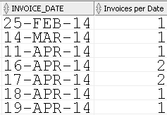

**14. Display the number of invoice totals that are less than $10.00. Use the Invoices table.**



**15. Display the number of vendors in each state. Use the Vendors table.**

**Partial Result Table (22 rows total)**

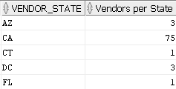

**16. Display the number of vendors in each state only if there are at least 3 vendors in that**

**particular state. Use the Vendors table.**

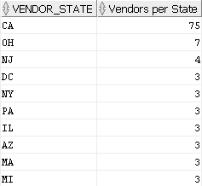

**17. Display the number in each terms id category. Use the Invoices table.**

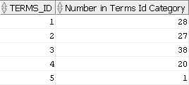

**18. Display the number of invoices in June 2014.You must use a WHERE clause (no HAVING**

**clause) to receive credit. Use the Invoices table.**

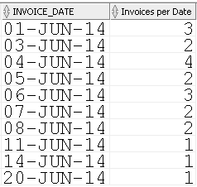

**19. Display the number of invoices in June 2014.You must use a HAVING clause (no WHERE**

**clause) to receive credit. Use the Invoices table.**



**20. Display the number of invoices that have the same number of days between when the**

**invoice was created and when it is due. Use the Invoices table.**

**Partial Result Table (51 rows total)**

